Retail Business Insights Agent
Databricks Data Agent Assignment

Prepared By: Charne’ Stasie
Date: 24 May 2024

TABLE OF CONTENTS

1. Introduction
2. Dataset Upload and Preparation
3. Creating the Data Agent
4. Agent Instructions
5. Testing the Agent
6. Validation Using SQL
7. Conclusion

INTRODUCTION
The purpose of this assignment was to create a data agent using Databricks Genie Spaces and a retail sales dataset. The project involved uploading and preparing data, creating a Genie data agent, writing instructions for the agent, testing business-related questions, and validating responses using SQL queries.

The goal of the agent was to help users analyse retail sales performance and gain business insights from the dataset.

2. DATASET UPLOAD AND PRESENTATION
The retail sales dataset was uploaded into Databricks using the Catalog feature. After uploading the CSV file, the dataset schema and columns were reviewed to ensure the data was loaded correctly.

The table included transaction information such as customer details, product categories, quantities purchased, prices, and total transaction amounts.

The dataset was prepared and inspected before being connected to the Genie data agent.

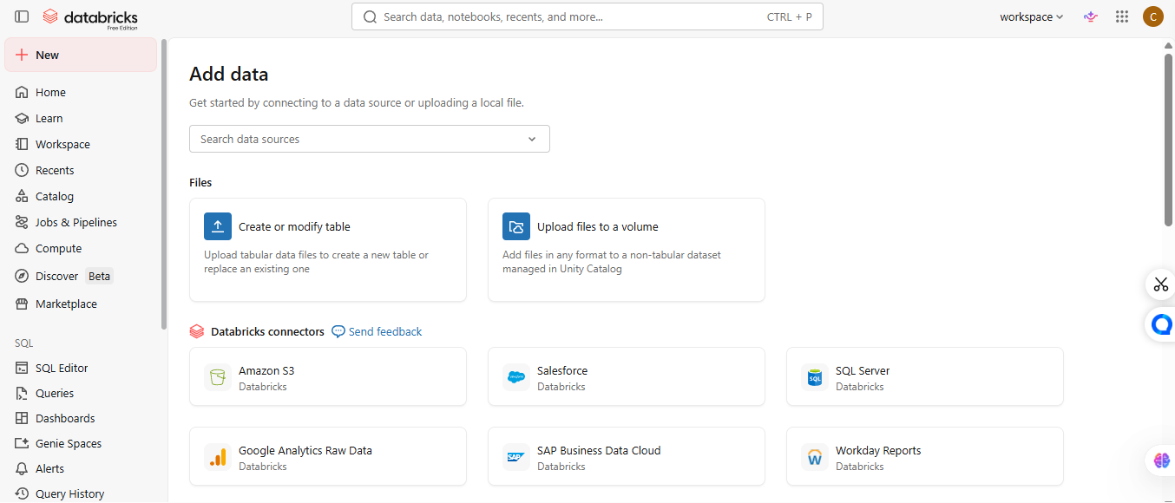
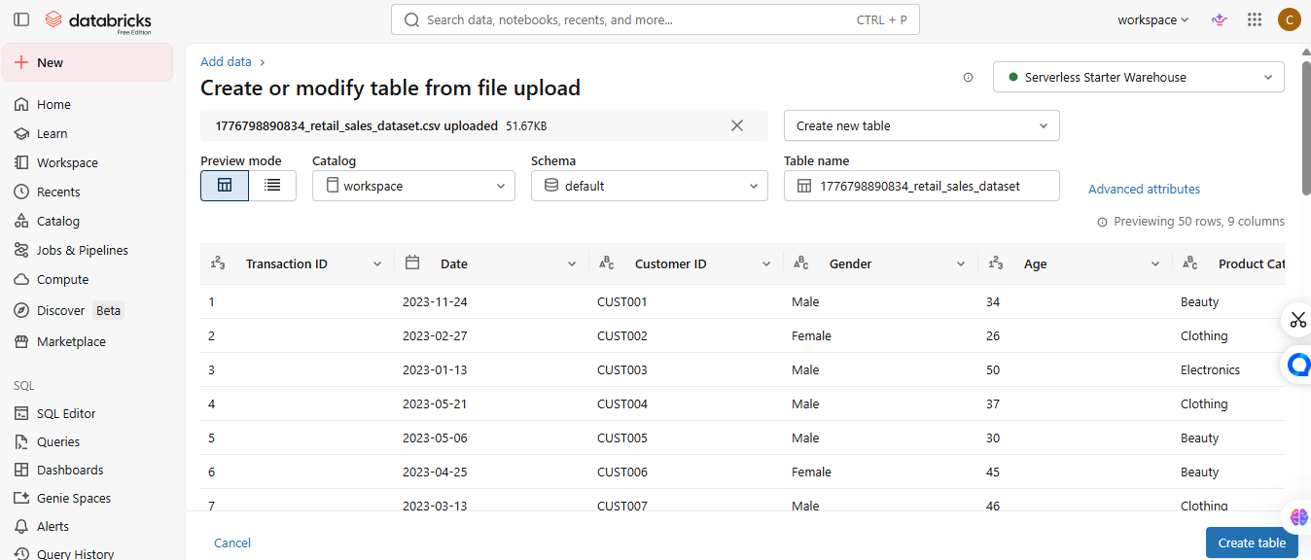
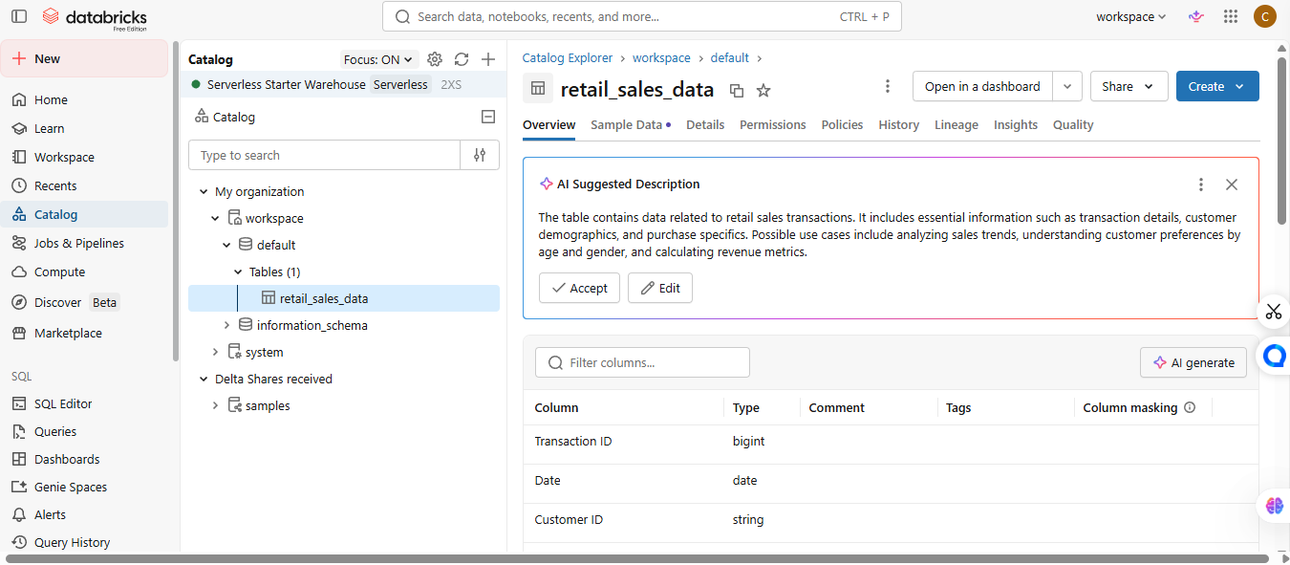

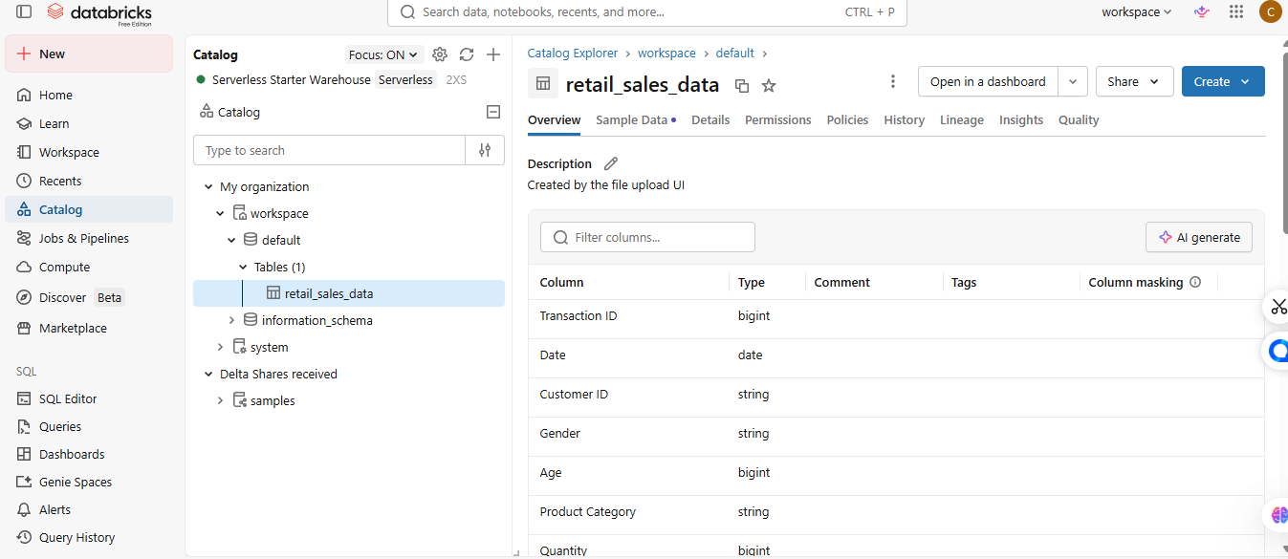
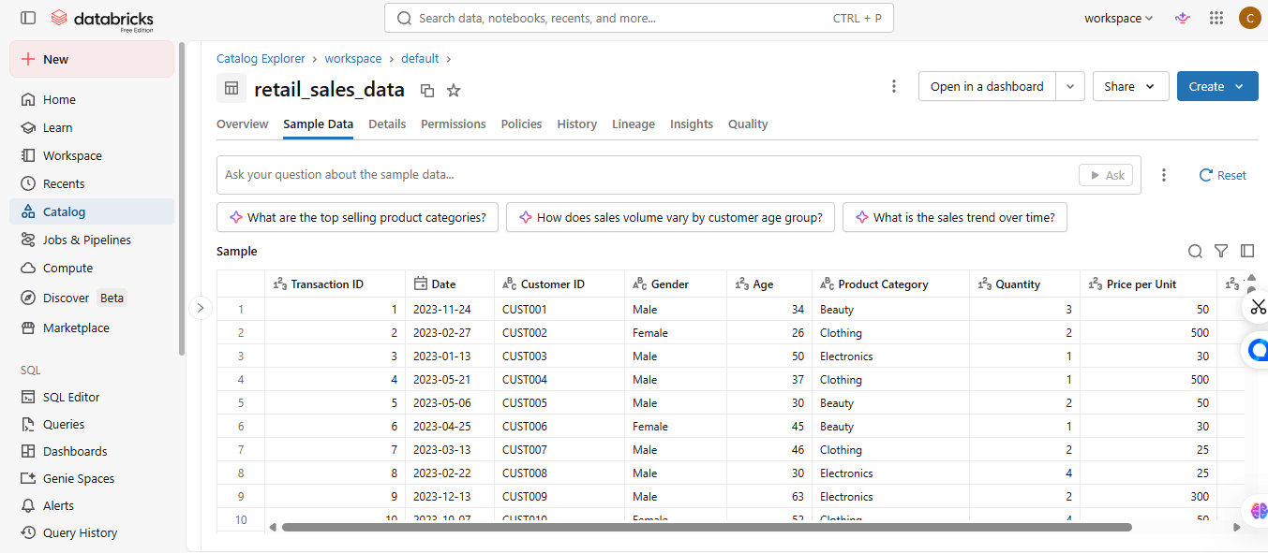

3. A Genie Space was created in Databricks and connected to the retail_sales_data table. The agent was named “Retail Business Insights Agent”.
The purpose of the agent was to answer business-related questions using the retail sales dataset and provide useful insights based on the available data.

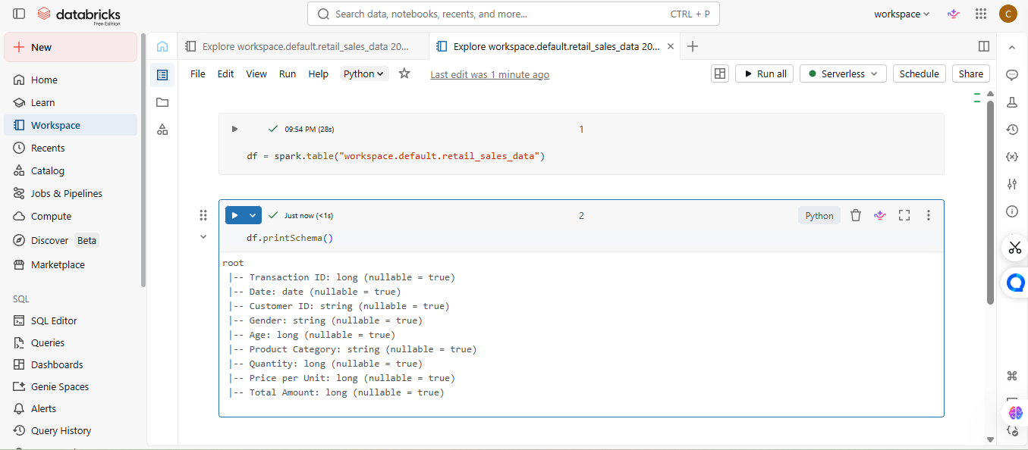
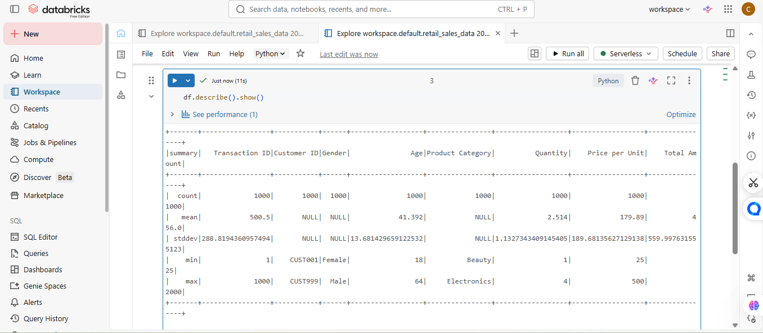
The retail_sales_data table was prepared and reviewed within Databricks. The schema, column structure, and metadata were inspected before connecting the dataset to the data agent.
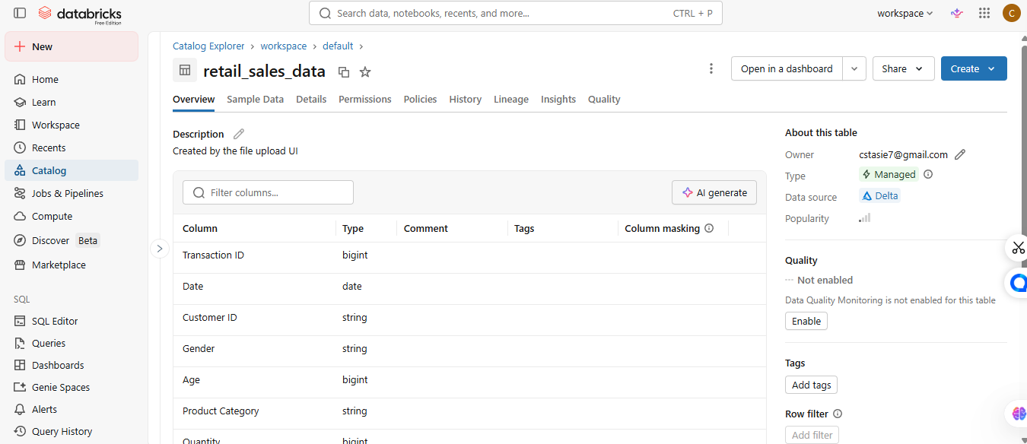
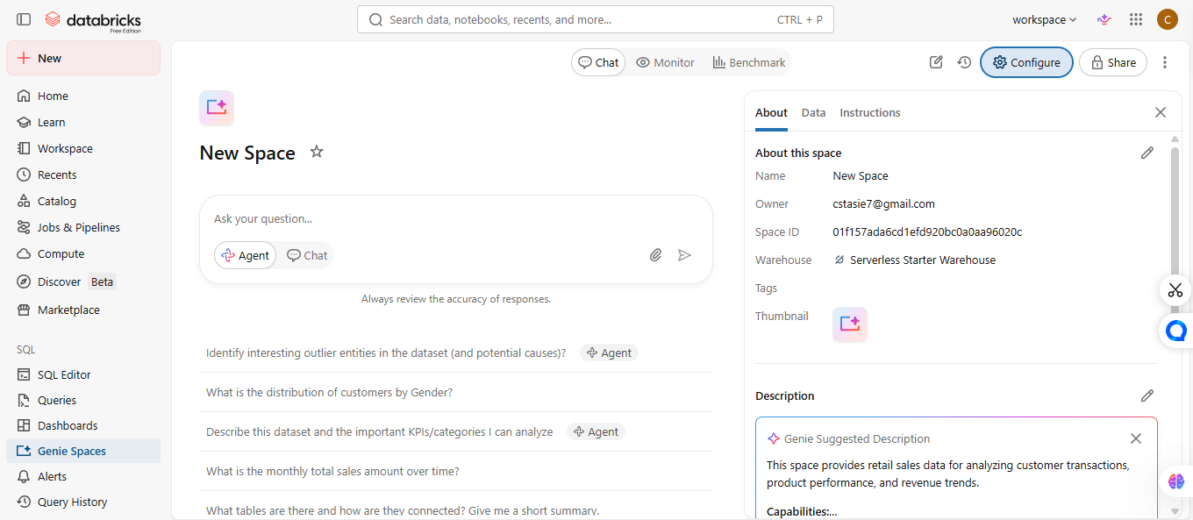
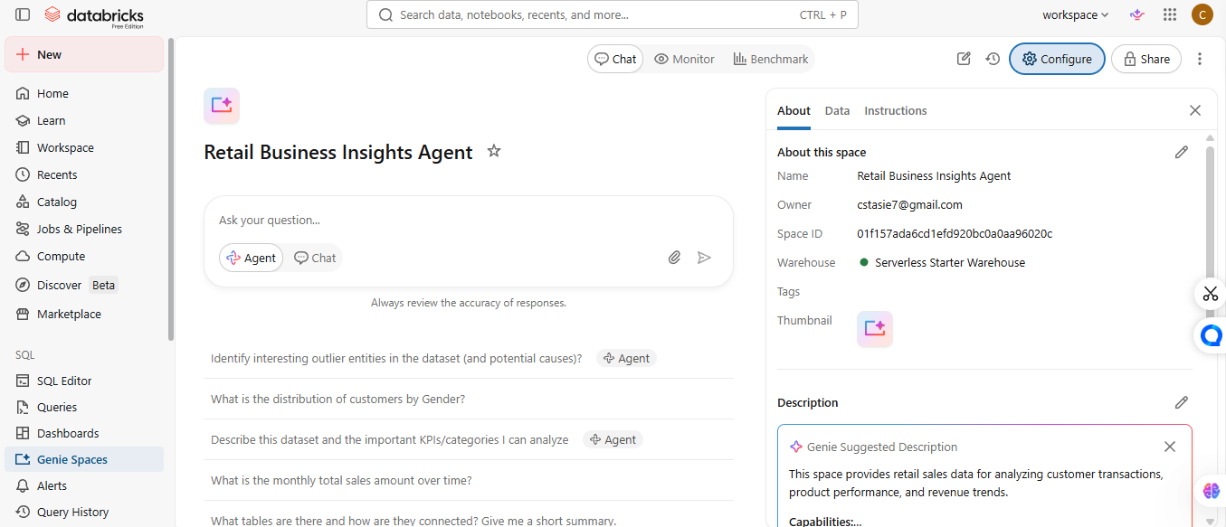

4. Instructions were added to guide the behaviour of the data agent. The instructions focused on ensuring that the agent provided business-focused responses, used only the available dataset, and explained answers clearly.
The instructions also required the agent to avoid making assumptions when data was missing.
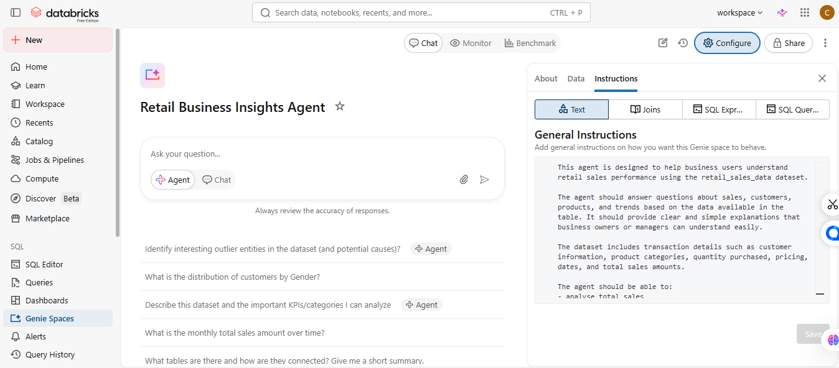

5. The data agent was tested using different business questions related to sales performance, customer behaviour, and product analysis. The questions included both simple and analytical queries to evaluate the quality of the responses generated by the agent.
Question | Summary of Response
What is the total amount of sales made? | The agent calculated the total sales generated from all transactions in the dataset.
Which product category made the most money? | The agent identified the product category with the highest total sales revenue.
Which product category performed the worst? | The agent identified the category with the lowest sales performance.
What is the average amount customers spend per transaction? | The agent calculated the average transaction value across all sales records.
Did males or females spend more overall? | The agent compared the total spending between male and female customers.
Which age group spends the most money? | The agent analysed customer age groups and identified the highest spending group.
What products are most popular with customers under the age of 30? | The agent analysed purchasing trends for customers younger than 30 years old.
How do sales change from month to month? | The agent identified monthly sales trends and changes over time.
Which month had the highest sales? | The agent determined which month generated the highest total revenue.
Who are the best customers based on how much they spend? | The agent identified customers with the highest overall spending in the dataset.
6. Three of the agent responses were validated using SQL queries in Databricks SQL Editor. The SQL results were compared with the answers generated by the Genie agent to check the accuracy of the responses.

Validation 1.
Question
What is the total amount of sales made?
SQL Query:
Evaluation
The SQL query result matched the response generated by the Retail Business Insights Agent. This confirmed that the total sales value calculated by the agent was accurate and reliable.
Validation 2.
Question
Which product category made the most money?
SQL Query:
Evaluation
The SQL results confirmed which product category generated the highest sales revenue. The answer provided by the agent matched the SQL output.

Validation 3.
Question
Did males or females spend more overall?
SQL Query:
Evaluation
The spending totals by gender confirmed the response generated by the agent. This showed that the agent correctly analysed the dataset.

CONCLUSION
This assignment demonstrated how Databricks Genie Spaces can be used to create a business-focused data agent using a retail sales dataset. The project showed how data agents can help users analyse sales information, identify trends, and support business decision-making.

The SQL validation process also confirmed that the responses generated by the agent were accurate and supported by the dataset.

Appendix with screenshots for all 10 questions.

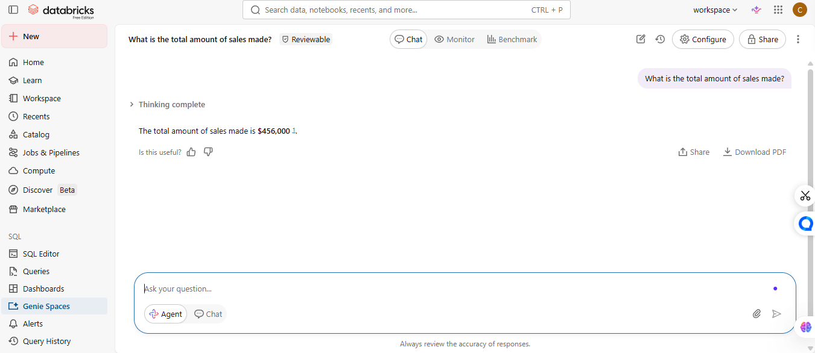

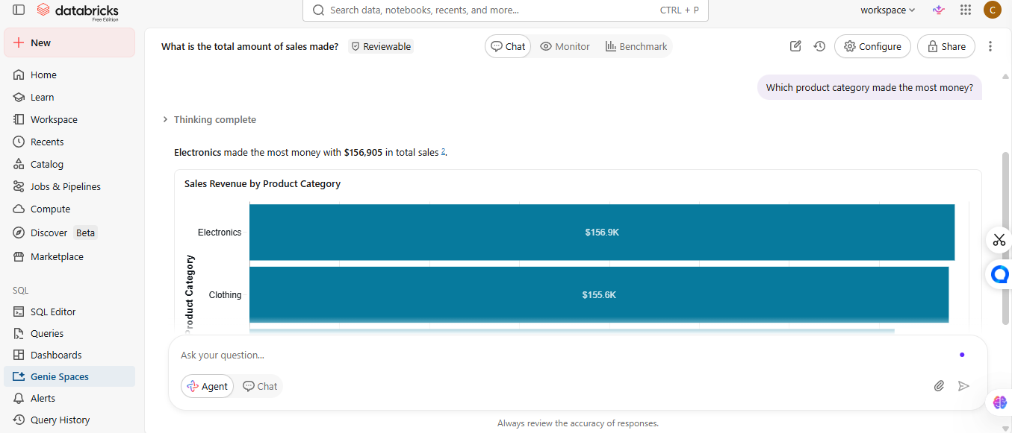

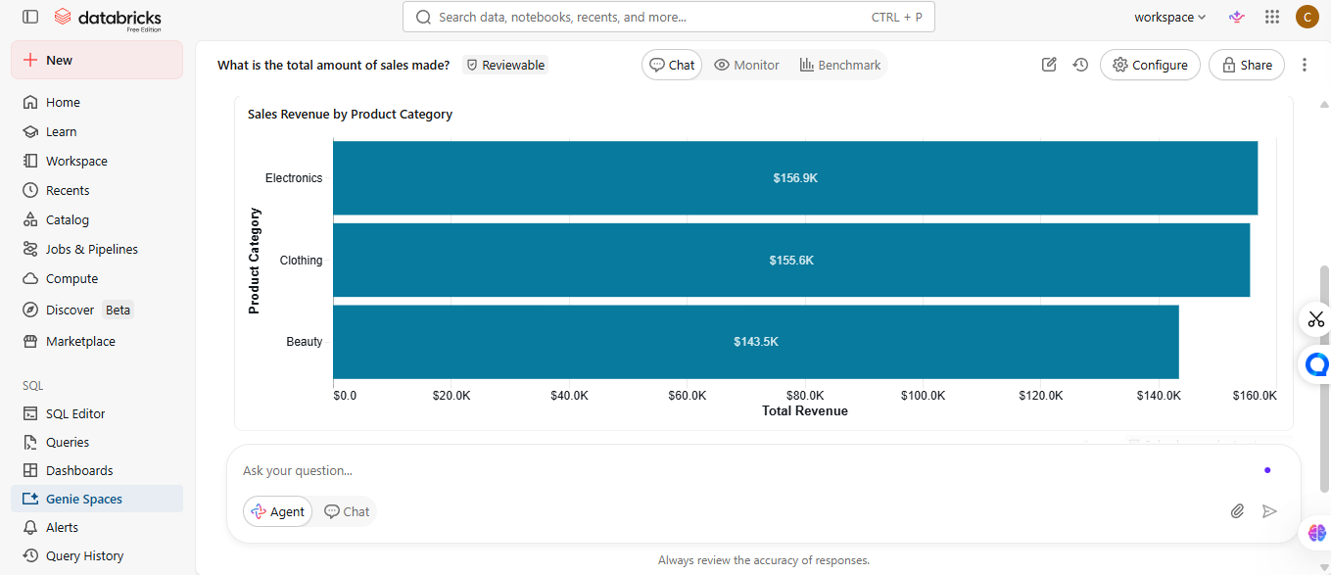
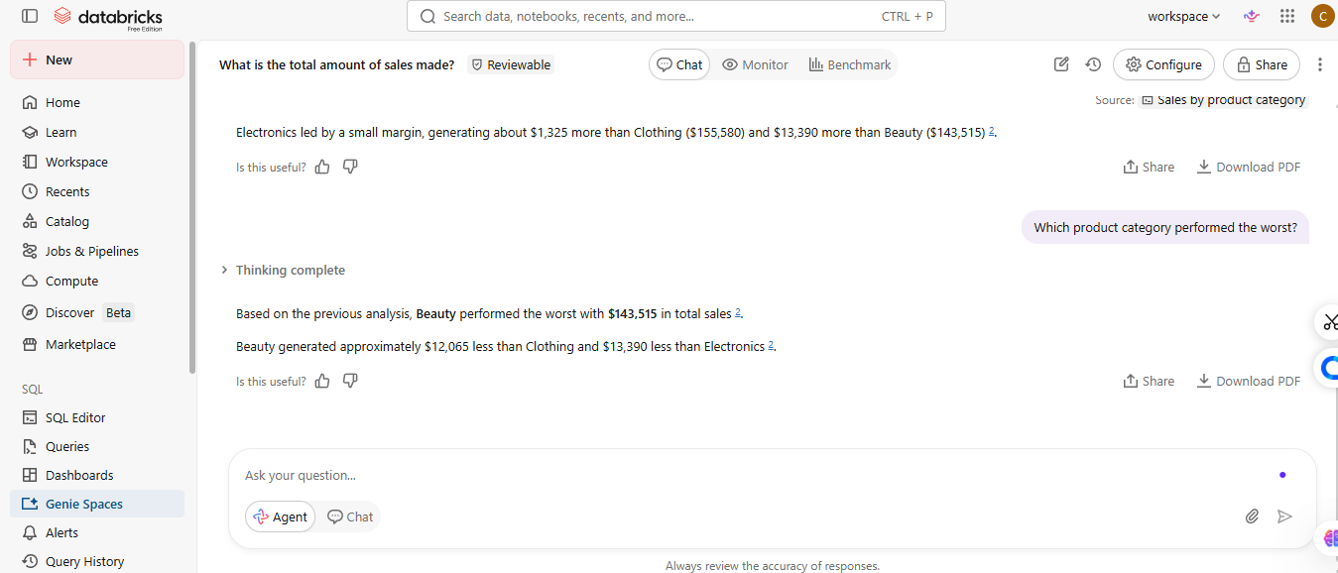
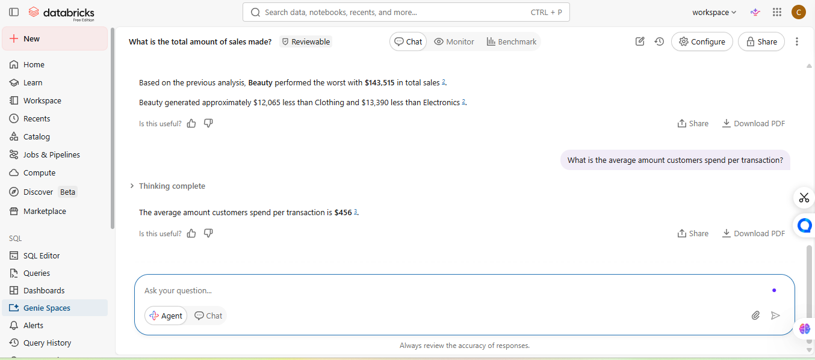

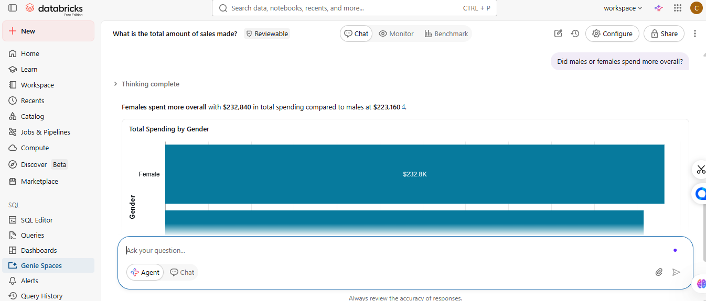

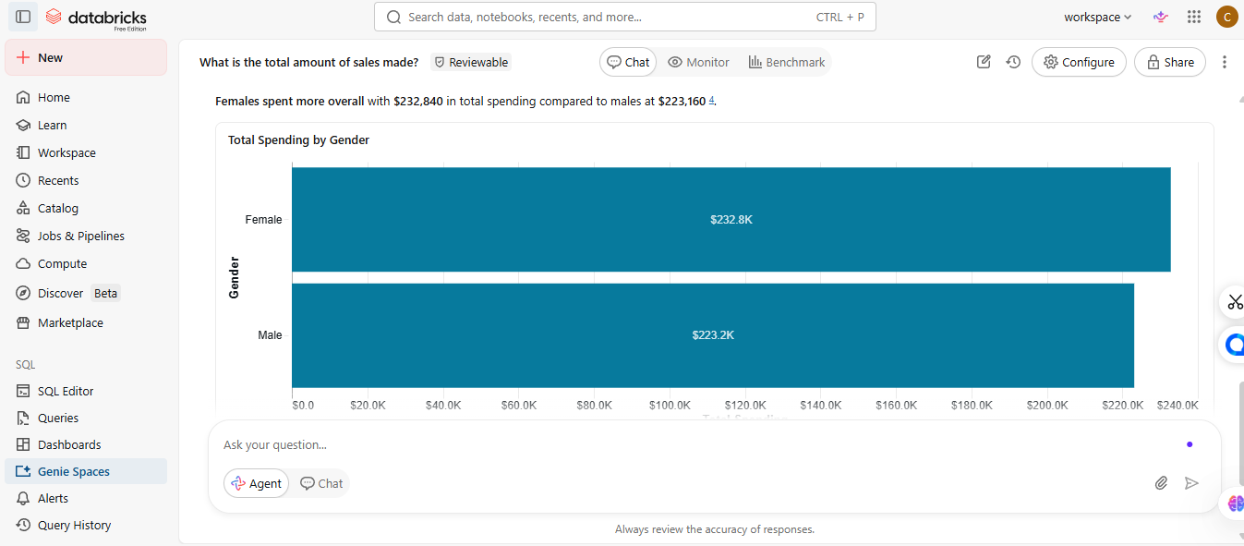

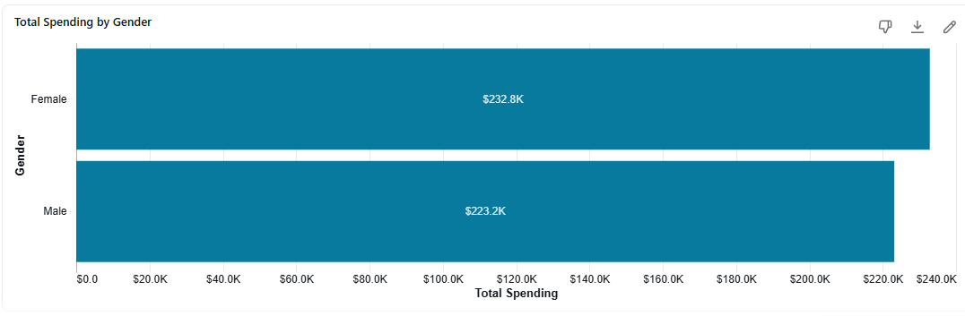
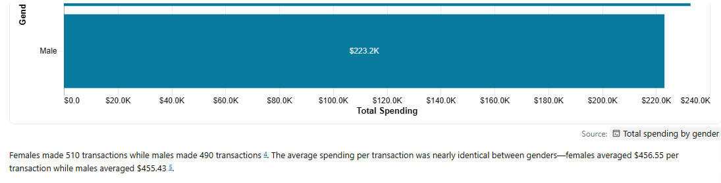
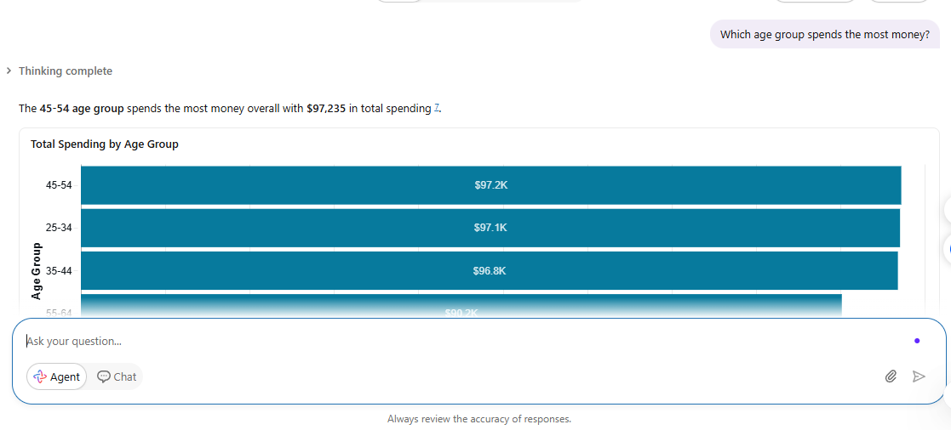
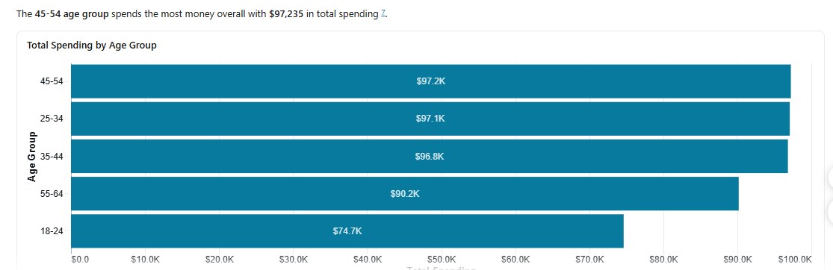
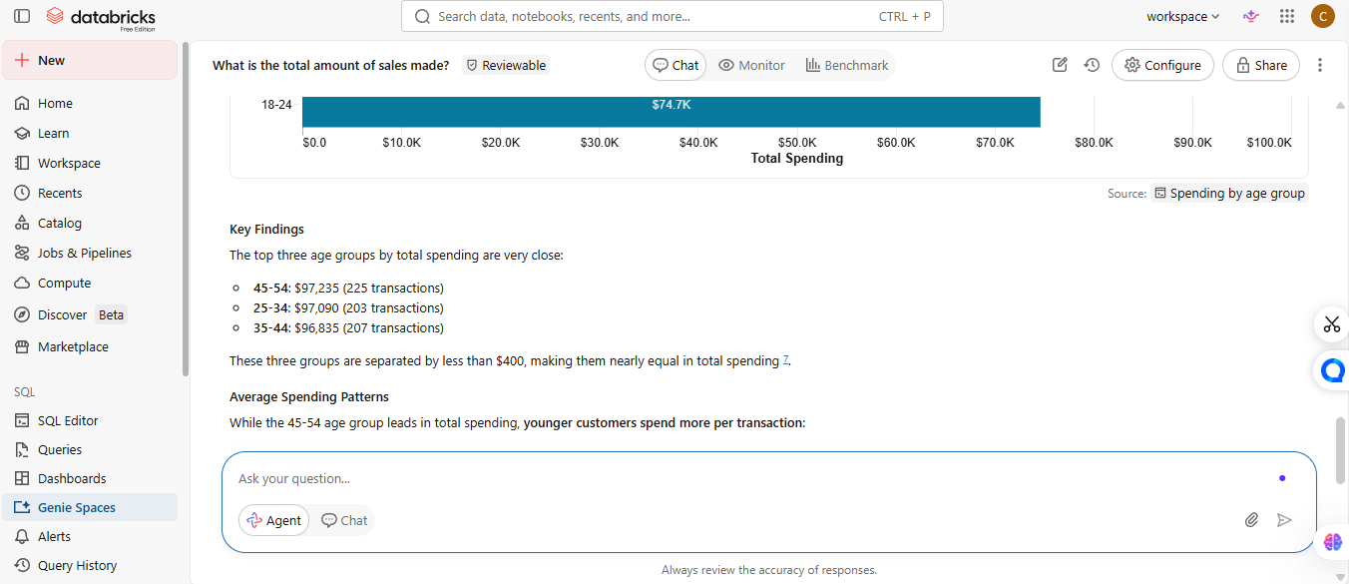
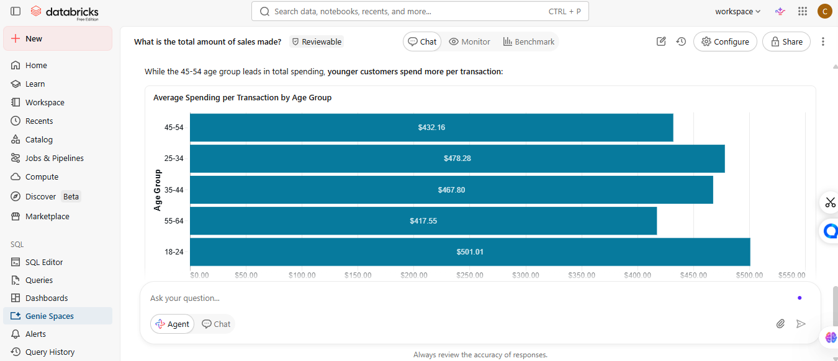
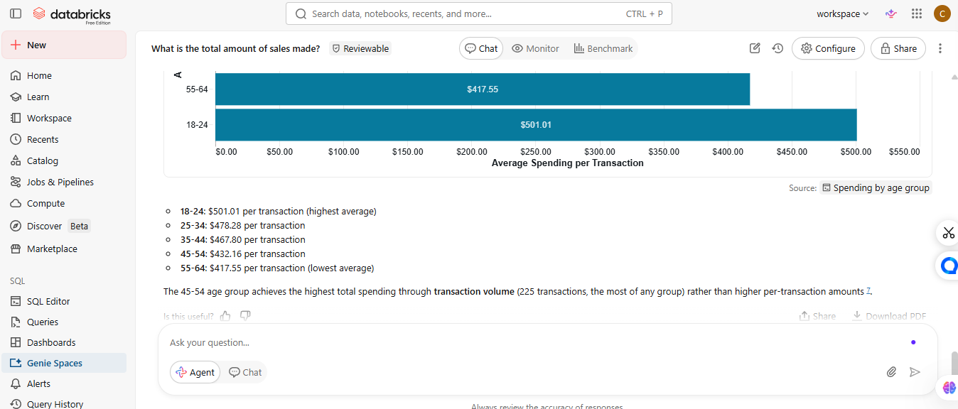
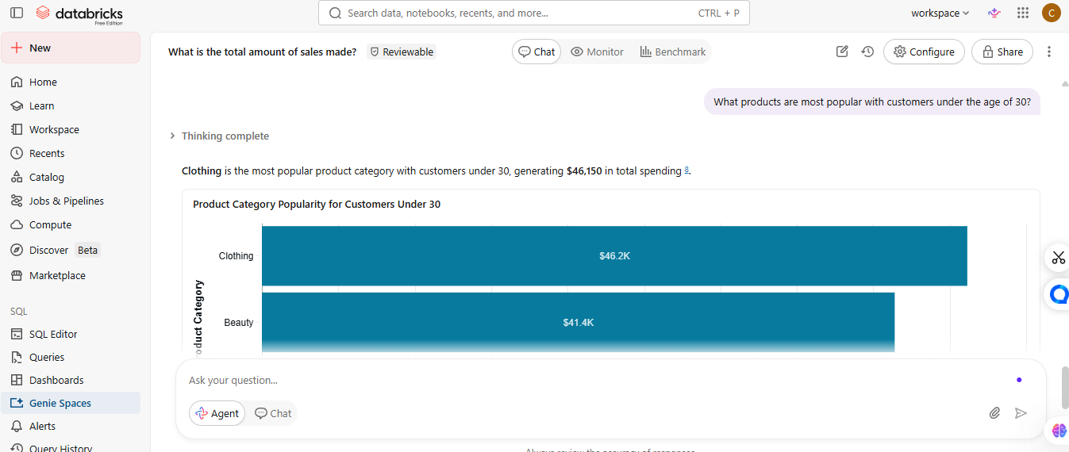
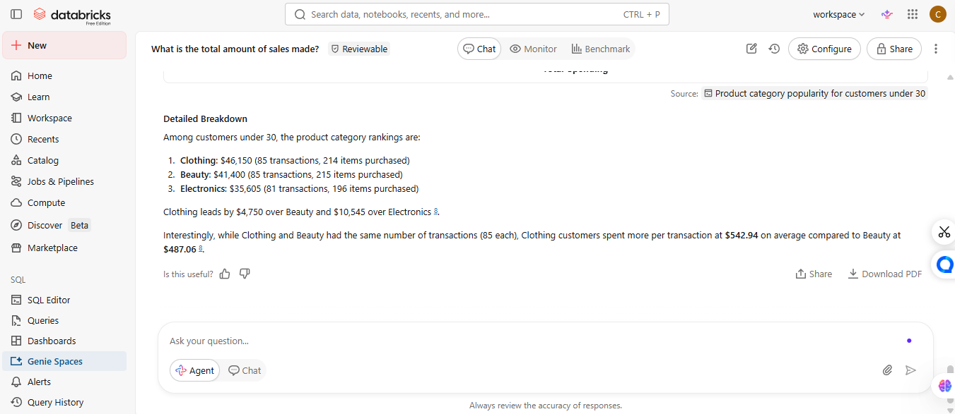
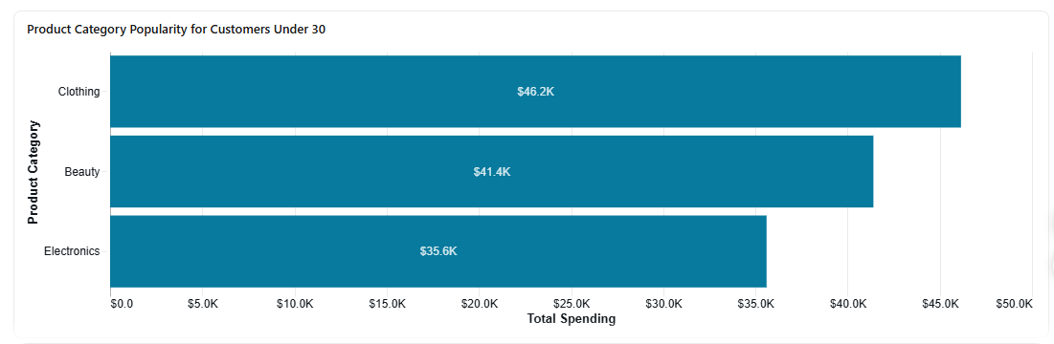
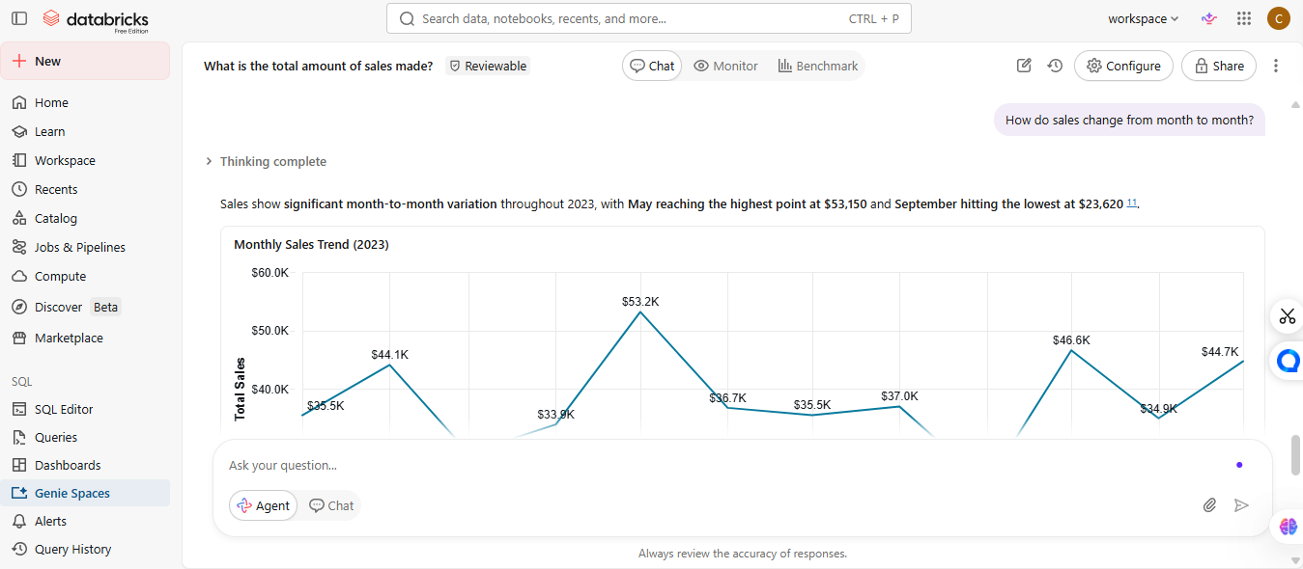
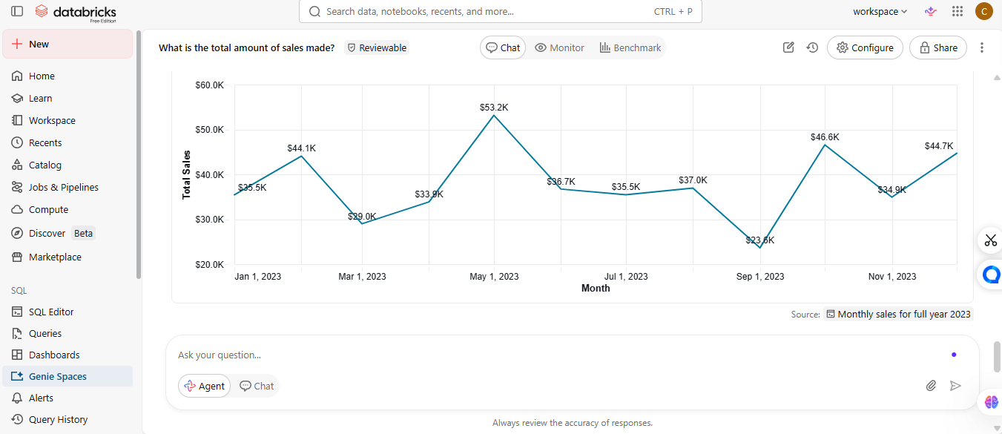
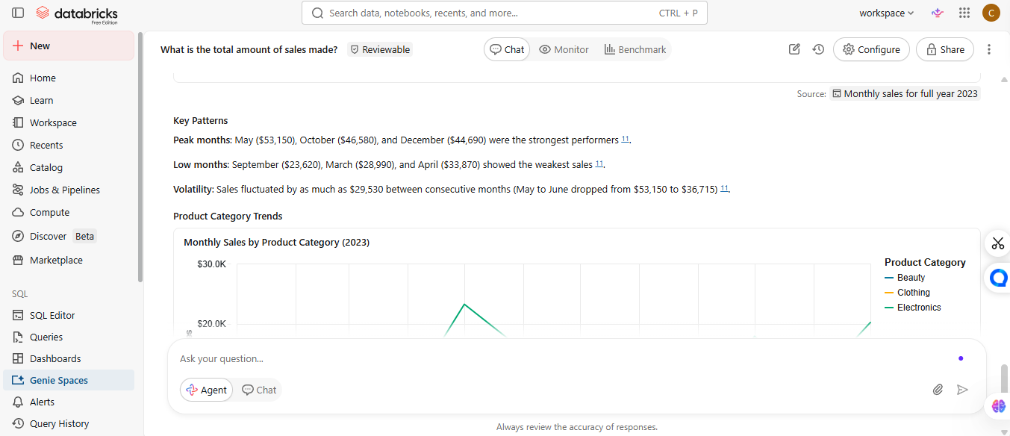

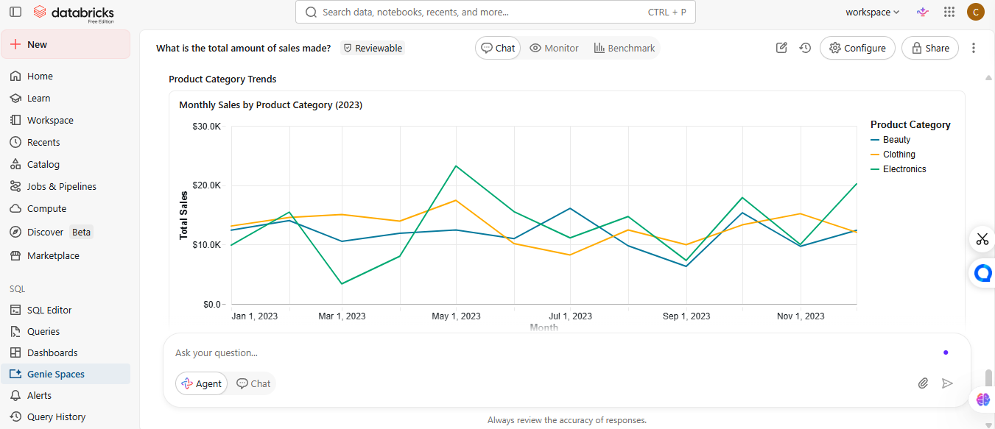
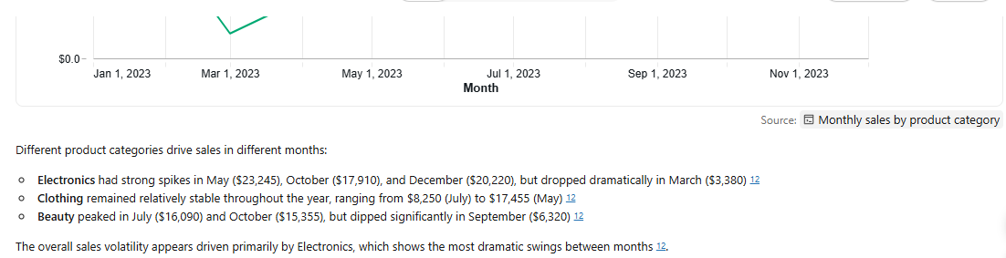
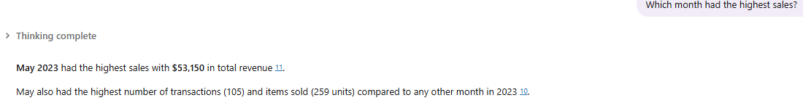
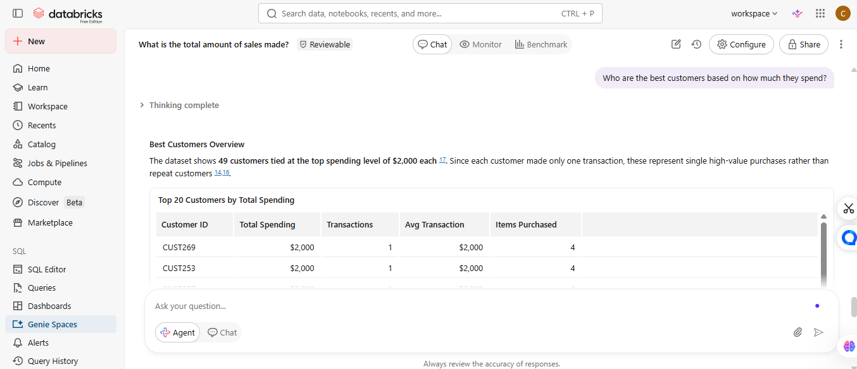
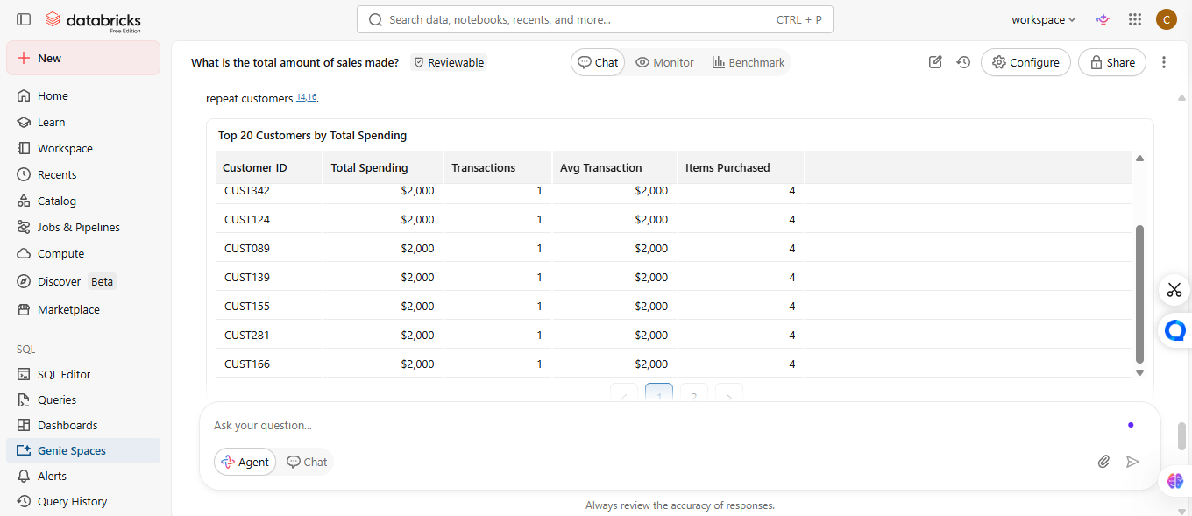

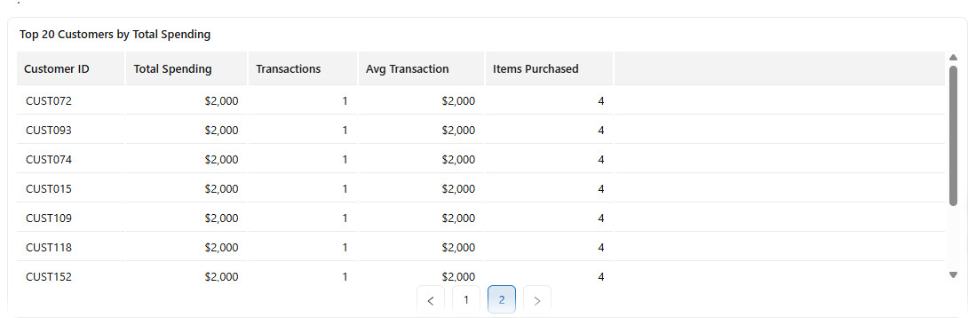
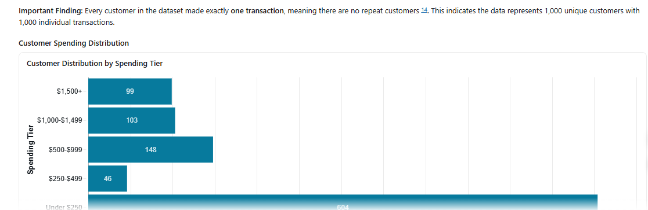
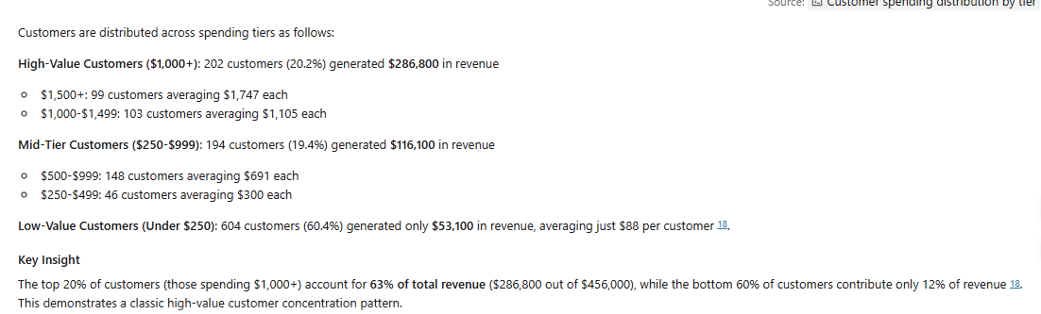

Step 7
- 
 